**Sexually Transmitted Infections – Notes**

**Sexually transmitted infections**: Infections transmitted by close body contact, usually with the genital organs.

STIs are caused by viruses, bacteria, fungi or parasites that are **passed from an infected person to a partner** during **sexual activity**.

Chlamydia:

* Around 90% of cases of non-specific genital infections (**NSGs**) are chlamydia.
* Caused by a microorganism called **Chlamydia trachomatis**.
* Although behaving like a virus in many ways, it’s a **highly specialised and adapted bacterium**; it can only reproduce when inside a living human cell and so was difficult to isolate.
* Transmitted by **vaginal or anal sex with an infected person** regardless of gender.
* **Most people show no symptoms** and are **unaware** that they’re infected (“silent infection”).
* Can be treated with **antibiotics** after diagnosis.

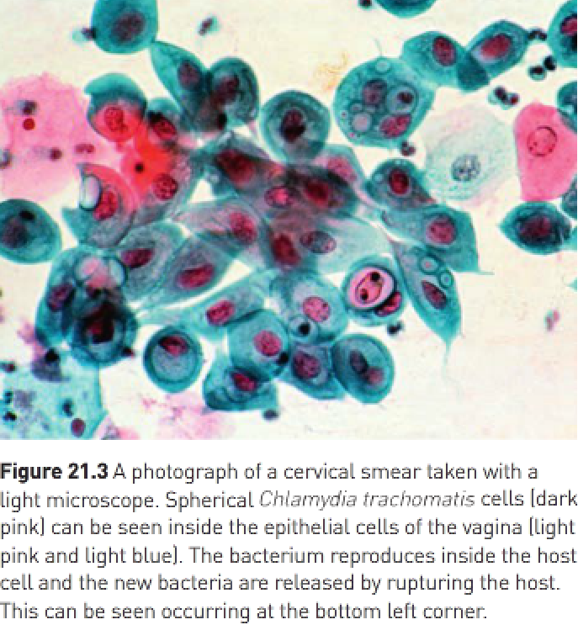

Non-specific urethritis (NSU):

* **Men** may develop non-specific urethritis (**NSU**) – inflammation of the urethra.
* **Pus is frequently produced** but when examined it shows no evidence of disease-causing microorganisms.
* When a microorganism is identified, it’s often Chlamydia trachomatis.

Epididymitis:

* If the chlamydia infection in males isn’t treated, the **bacterium can spread to the epididymis** where it causes **inflammation** – this is called **epididymitis**.
* Causes pain and swelling of the epididymis.
* **Most women have no symptoms** and therefore no idea they have chlamydia.
* If **untreated**, it can lead to **infertility, eye infection and arthritis**.
* Some women show symptoms of pelvic inflammatory disease (**PID**) – **inflammation** of the **organs in the pelvic region** e.g., the urethra, uterus and uterine tubes; continual inflammation of the uterine tubes may lead to **blockage by scar tissue** and thus **infertility**, and implantation of an embryo outside of the uterus (**ectopic pregnancy**) may occur.
* If the infected woman is pregnant, there’s **70% chance** that the disease will be **passed to the foetus during birth**; the baby may then suffer from conjunctivitis, nose and throat infections or pneumonia; may cause significant increase in risk of having a premature birth or stillborn child.
* **Urine test** or **analysis of a swab from the vagina, cervix, anus or penis** can **test** for chlamydia.
* The usual treatment is a course of **antibiotics**.

Genital herpes:

* Caused by the **Herpes simplex virus**.
* There are 2 forms:

1. Herpes simplex type 1 (HSV1) – Usually produces “**cold sores**” **on the lips** but can **also affect genitals**.
2. Herpes simplex type 2 (HSV2) – Provides **blisters on the genital organs**.

* Transmitted by **skin-to-skin contact** and can therefore be passed on during **genital, oral or anal sex**.

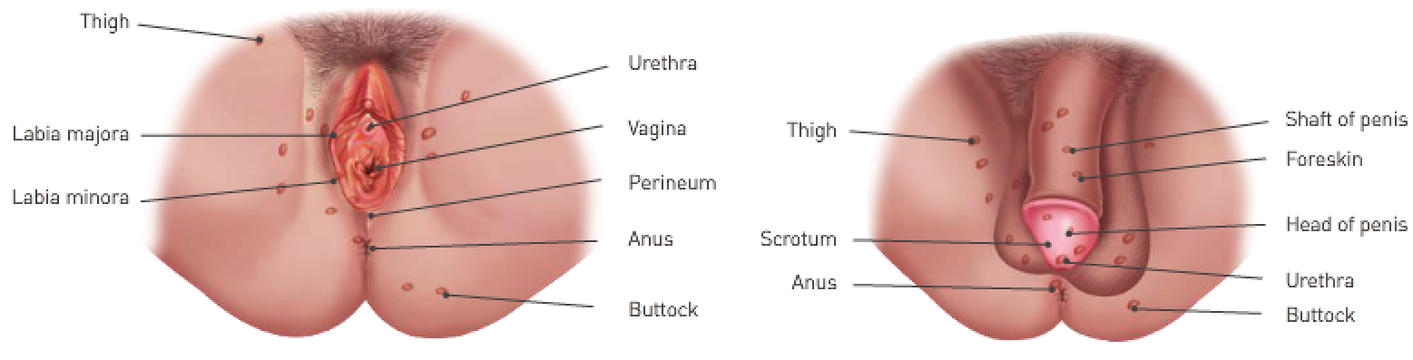

First episode of genital herpes:

* Usually the most severe.
* **Blisters** develop in areas e.g., penis in males and labia and vagina in females.
* Blistering may be accompanied by **flu-like symptoms** or a **rash**.
* Blisters break, forming **ulcers** and then forming **scabs**.
* **Healing** occurs over a period of **1-2 weeks** but some of the virus passes into the nervous system where it remains for life; it can **reinfect the skin or mucus membranes of genital organs at any time** and the **blisters can recur** for the rest of the person’s life.
* Recurrent episodes are usually **less painful** and **shorter**.
* Virus **can still be passed onto others** even when there are **no symptoms**.

Genital herpes:

* Herpes simplex virus can be transmitted from an **infected mother to a baby during birth**, which may cause serious **malformations** and **life-threatening diseases** (uncommon).
* There’s no way of removing the herpes virus once infected; treatment includes medication to reduce pain, saline dressings to clean up blisters and sexual abstinence for the duration of the eruption, and antiviral drugs specific to herpes can be prescribed to reduce severity and length of an attack.

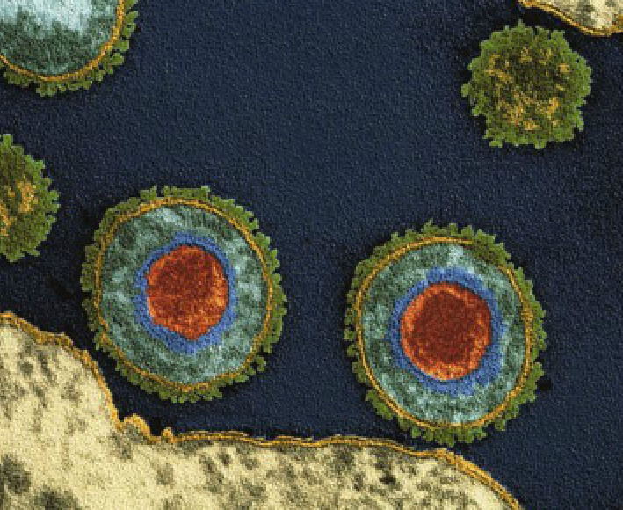

Genital warts:

* Usually found on the genital area – vagina, labia, cervix or penis – but may **occasionally** be found around the **anus or in the throat**.
* Caused by **HPV**.
* Passed on by a **sexual partner infected by the virus**.
* A newborn can become infected during **passage through the birth canal**.
* Some types of HPV can cause cervical cancer but those that cause genital warts don’t cause cancer.

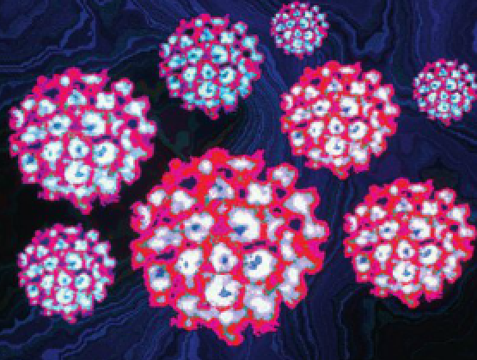

Human immunodeficiency virus (HIV):

* **Weakens the body’s immune system** so the infected person is **susceptible to other microorganisms** and **some forms of cancer**.
* Almost all cases of HIV infection eventually result in acquired immunodeficiency syndrome (**AIDS**).
* It’s a retrovirus, containing an RNA core rather than a DNA core.
* Infects leukocytes known as T-lymphocytes; inside the host cells, the virus uses an enzyme called reverse transcriptase to convert its RNA into DNA; DNA then produces millions of copies of itself that are released into the blood to infect more T-lymphocytes.
* Around **a month after the first infection**, an infected person may suffer **flu-like symptoms** and a **long period during which the person is seemingly fit and well then follows**; during this period, the virus contributes to destroy T-cells until the number of these cells is so low that the immune system is **no longer able to resist bacterial, viral or fungal infection** and **cancers are likely to develop**; the patient now has AIDS.

HIV may spread:

* By unprotected sexual intercourse with an infected person.
* By the sharing of needles or syringes with an infected person.
* From an infected mother to the child during pregnancy, childbirth or breastfeeding.
* By blood transfusions in countries where blood isn’t carefully tested.
* By implements that pierce the skin if they haven’t been sterilised.

The following preventive measures should be taken:

* Don’t have sexual intercourse or inject drugs.
* Have protected sex until both partners are sure they won’t have sex with anyone else.
* Always use a condom.
* Never share things likely to have human blood on them.
* Wash and cover any open cuts or sores on the skin.

Diagnosis of HIV infection:

* Post-exposure prophylaxis (PEP) – Involves a course of drugs that must be taken for a month (must be started within 3 days of possible exposure to HIV).
* Can be diagnosed with tests that detect the presence of an HIV antibody in the blood.
* Viral load: Refers to the amount of virus in he blood and gives an indication of the activity of the virus

Treatment:

* Patients are usually given a combination of many drug classes (“cocktail of drugs”).
* The content of a patient’s multi-drug therapy depends on how high the viral load is and whether they’ve had previous treatment with some of the drugs to which the virus has developed resistance; slows the replication and progression of HIV and in some patients reduces the viral load to amounts that can’t be detected.
* Virus remains in the body so **therapy must be continued indefinitely**.

Trichomoniasis:

* Caused by the protozoan **Trichomanias vaginalis**.
* Causes **inflammation** of the **vaginal mucus membranes** in **women** and **urethra** in **men**.
* Symptoms in women include **vaginal discharge** and **severe vaginal itch**; men often don’t show symptoms but can still transmit the infection.
* Can be cured quickly and easily with antibiotics.
* Spread by vaginal discourse and use of a condom will prevent infection.

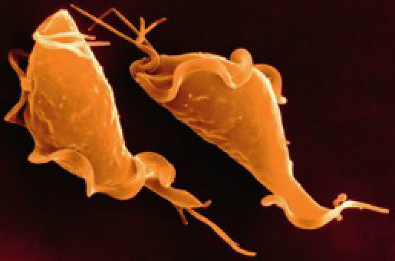

Pubic lice and scabies:

* Both cause **intense itching in the genital area**.
* Public lice are insects called **Pthirus pubis** and are usually confined to pubic and anal regions of the body.
* Scabies are caused by a mite, **Sarcoptes scabiei**, and prefer the genital regions, wrists and finger webs; these infected regions become extremely itchy, especially at night.
* Both can be transmitted by **sexual contact** or through **prolonged, warm, close contact**.
* Both are treated by lotions that are applied to the skin which kill the lice/scabies and their eggs.



(Public lice)

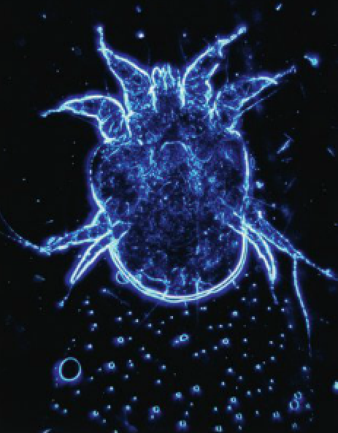

(Scabies mite)

Gonorrhoea:

* Mainly affects the mucus membranes of the excretory and reproductive systems, the rectum and occasionally the eyes and throat.
* Caused by a bacterium, Neisseria gonorrhoea (commonly known as gonococcus).
* Normally transmitted during sexual intercourse.
* Affects both males and females and symptoms appear around 2-10 days after infection.
* Incubation period: Period between infection and appearance of symptoms.

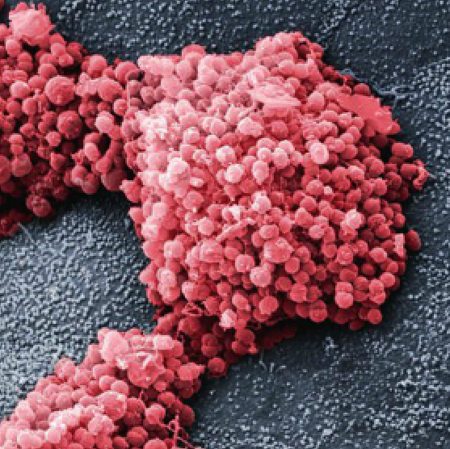

In males:

* Bacterium enters the urethra during intercourse with an infected partner.
* After the incubation period, inflammation in the urethra results in a burning feeling in the penis and extreme pain when passing urine.
* Later there’s a yellow discharge of pus from the penis.
* If untreated, the urethra may become permanently constricted, resulting in difficulty urinating; infection can spread to other organs of the body e.g., testes (causing eventual sterility), joints (causing a type of arthritis) or to the heart or eyes.

In females:

* There may be no early symptoms, or the symptoms may go unrecognised (more than 70% show no symptoms).
* Gonococcus enters the vagina during intercourse with an infected male and infection occurs most often in the urethra or cervix.
* No pain so any pus produced is taken to be normal vaginal discharge.
* Untreated, the infection spreads to the oviducts and abdominal membranes; oviduct infection may cause permanent blockage and thus sterility.
* Because of seriousness if untreated and lack of symptoms, women who have sexual intercourse with a number of partners are advised to have smears taken on a daily basis to check for possible infection.
* Discharge from affected mucus membranes is the source of infection and the bacteria are transmitted by direct contact (usually sexual).
* As gonorrhoeal infection in women occurs in the cervix and vagina, children born to infected women may be infected during birth; gonococci may enter through the baby’s eyes, causing an acute eye infection that can lead to blindness.
* Oral sex with an infected person can result in infection of the throat regardless of gender.

Treatment:

* Antibiotics are used and normally result in an easy and effective cure (provided treatment is begun early enough) although strains of gonococcus that are resistant to antibiotics have evolved and in some cases are becoming increasingly difficult to cure.

Syphilis:

* Caused by a thin, flexible, spiral-shaped bacterium, Treponema pallidum, which can only live in humans and some other mammals.
* Usually contracted by direct sexual contact.
* Affects men and women in the same way and follows 4 stages if untreated.

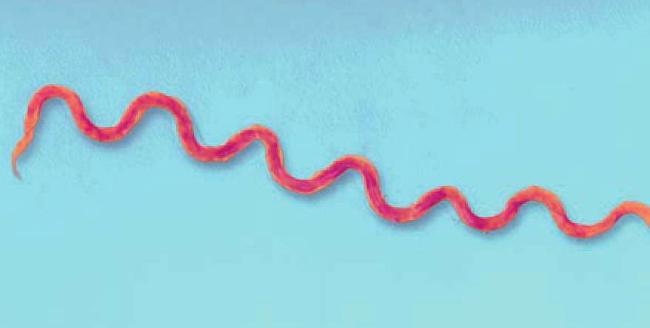

1. Primary stage:

* Usually begins when the syphilis **bacterium enters through any break in the skin**; such infection takes place during **sexual activity** with an infected person.
* Bacteria multiply and spread through the whole body during the **incubation period** (usually **2-4 weeks**).
* The first symptom is **one or more small sores** known as **chancres** which usually occur on the sex organs or elsewhere on the skin e.g., lips, finger or eyelid.

1. Secondary stage:

* Symptoms include skin rashes, sore or ulcerated mouth or throat, mild fever and disorders of the bones or eyes; sometimes quite mild so isn’t taken seriously but the patient is highly infectious during this stage.
* Lasts around 2 years and all symptoms eventually disappear even without medical treatment.

1. Latent stage:

* Begins when symptoms from the primary and secondary stages go away.
* No noticeable symptoms and may last for many years.
* The infection can’t be passed on to others but sometimes symptoms of the secondary stage return and then the infection can be passed to other while symptoms persist.

1. Tertiary (late) phase:

* Only a minority of people infected with syphilis undergo this stage.
* When symptoms appear again (5-40 years after initial infection) the results may be devastating – syphilitic heart disease, insanity, blindness, weakening of the blood vessels, physical incapacity and many other serious afflictions.

Treatment:

* Antibiotics for all stages of syphilis and during the primary stage cure is relatively easy.
* Surgery becomes necessary in the later stages.
* If the bacterium crosses the placenta of a pregnant woman and enters the foetal circulation, the foetus can go through all the stages of syphilis before birth and may suffer permanent damage to the heart, nervous system, joints or other organs.
* Blood tests for syphilis are usually carried out during pregnancy and antibiotics can be used to treat both the infected woman and foetus.

Control of sexually transmitted infections:

* Safe sex:
* Involves taking precautions to ensure your partner’s semen, vaginal fluids or blood don’t enter your partner’s body.
* Parts of the body that may be infectious e.g., warts or herpes sores should be covered or contact with these parts avoided.
* Involves use of a condom for vaginal or anal intercourse; this prevents exchange of body fluids and prevents pregnancy.
* A condom or dental dam (a square of very thin latex that can be used as a barrier) can be used for oral sex.
* Treatment and contact tracing:
* A person may be unaware that he/she has an STI due to the often mild nature of the symptoms.
* By tracing the sexual contacts of patients, the clinics aim to locate and treat people who unknowingly have STIs.

Education:

* If people know the dangers and are aware of the symptoms, they’re more likely to seek treatment early when the disease is more easily cured and before they pass it onto others.

|  |  |  |  |
| --- | --- | --- | --- |
| **Sexually transmitted disease**: | **Cause(s)**: | **Symptom(s)**: | **Treatment(s)/diagnosis**: |
| Chlamydia | Vaginal or anal sex with an infected person. | Most women show no symptoms.  If untreated in women, it can lead to infertility, eye infection and arthritis.  Some women show symptoms of pelvic inflammatory disease (PID) – inflammation of the organs in the pelvic region.  Continual inflammation of the uterine tubes may lead to blockage by scar tissue and thus infertility, and implantation of an embryo outside of the uterus (ectopic pregnancy) may occur.  Men may develop non-specific urethritis (NSU) – inflammation of the urethra; pus is frequently produced.  If left untreated in men, the bacterium can spread to the epididymis where it causes inflammation – epididymitis – pain and swelling of the epididymis. | Urine test or analysis of a swab from the vagina, cervix, anus or penis can test for chlamydia.  The usual treatment is a course of antibiotics. |
| Genital herpes | Skin-to-skin contact with an infected person. | Blistering (in penis in males and labia and vagina in females).  Flu-like symptoms.  Rash. | Medication to reduce pain.  Saline dressings to clean up blisters.  Sexual abstinence for the duration of the eruption.  Antiviral drugs. |
| Genital warts | Human papillomavirus (HPV).  Passed on by a sexual partner infected by the virus. | Genital warts in the genital area or cervical cancer. | Medication to fight off warts (warts often return after treatment). |
| HIV | Unprotected sexual intercourse with an infected person.  Sharing of needles or syringes with an infected person.  From an infected mother to the child during pregnancy, childbirth or breastfeeding.  Blood transfusions in countries where blood isn’t carefully tested.  Implements that pierce the skin if they haven’t been sterilised. | Flu-like symptoms (around a month after first infection) after which a long period during which the person is seemingly fit and well then follows. | Post-exposure prophylaxis – Course of drugs that must be taken for a month (must be started within 3 days of possible exposure to HIV).  Tests that detect the presence of an HIV antibody in the blood.  Combination of many drug classes (“cocktail of drugs”).  Therapy must be continued indefinitely. |
| Trichomoniasis | Vaginal discourse. | Inflammation of the vaginal mucus membranes in women and urethra in men.  Vaginal discharge and severe vaginal itch.  Men often don’t show symptoms. | Antibiotics. |
| Public lice and scabies | Prolonged, warm, close contact. | Intense itching in the genital area (possibly wrists and finger webs). | Lotions that are applied to the skin which kill the lice/scabies and their eggs |
| Gonorrhoea | Sexual intercourse with an infected person.  In women:  Discharge from affected mucus membranes. | In men:  Burning feeling in the penis.  Extreme pain when passing urine.  Yellow discharge of pus from the penis.  Difficulty urinating.  Eventual sterility.  Arthritis. | Antibiotics. |
| Syphilis | Direct sexual contact. | Primary stage (1st):  One or more small sores usually on the sex organs.  Secondary stage (2nd):  Skin rashes.  Sore or ulcerated mouth or throat.  Mild fever.  Disorders of the bones or eyes.  Tertiary stage (4th):  Syphilitic heart disease.  Insanity.  Blindness.  Weakening of the blood vessels.  Physical incapacity.  Many other serious afflictions. | Blood test to test for syphilis.  Antibiotics (for primary stage).  Surgery (for later stages). |

|  |  |
| --- | --- |
| **Curabl**e: | **Incurable**: |
| Chlamydia | Genital herpes |
| Trichomoniasis | HPV |
| Pubic lice and scabies | HIV/AIDS |
| Gonorrhoea |
| Syphilis |